CO5 ASSESSMENT TOOL 2 PSEUDOCODE WRITING

CSA0652-Design and Analysis of Algorithms for Complexity Analysis.

DONE BY:
Name: J.Harikarapandian
Reg No: 192421073
SIMATS Engineering

Supervisor:
Dr. MARY HARIN FERNANDEZ , Professor
Dr. S. PRADEEP KUMAR, Professor

Question 1: Word Search Problem (Grid Search)
Source Code (word_search_problem.py)

def exist(board, word):
rows, cols = len(board), len(board[0])

def dfs(r, c, index):
if index == len(word):
return True

if (r < 0 or c < 0 or
r >= rows or c >= cols or
board[r][c] != word[index]):
return False

temp = board[r][c]
board[r][c] = "#"

found = (dfs(r + 1, c, index + 1) or
dfs(r - 1, c, index + 1) or
dfs(r, c + 1, index + 1) or
dfs(r, c - 1, index + 1))

board[r][c] = temp
return found

for i in range(rows):
for j in range(cols):
if dfs(i, j, 0):
return True

return False

grid = [
['A','B','C','E'],
['S','F','C','S'],
['A','D','E','E']
]

Output:
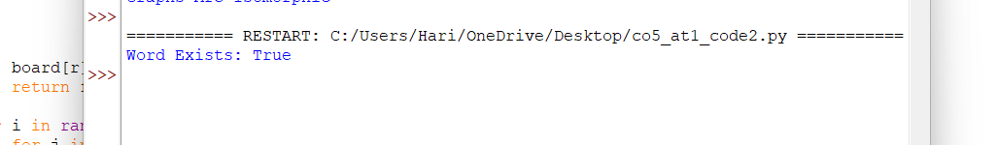

Word Exists: True
Report
Title
Word Search Problem Using Backtracking
Problem Analysis
The objective is to determine whether a given word exists in a two-dimensional character grid. Characters must be connected horizontally or vertically, and each cell can be used only once in a path.
Inputs
- Character Grid
- Target Word
Output
- True if the word exists
- False otherwise

Backtracking Approach
- Start from every cell in the grid.
- Match the current character with the word.
- Recursively explore adjacent cells.
- Mark visited cells temporarily.
- Backtrack when a path becomes invalid.
- Return True if the entire word is matched.
Pruning Strategy
- Stop immediately when characters do not match.
- Stop when indices exceed grid boundaries.
- Avoid revisiting already used cells.
Time Complexity
- O(M × N × 4ᴸ)
Where:
- M = Rows
- N = Columns
- L = Length of the word
Result
The word "ABCCED" exists in the grid.

Question 2: Bin Packing Approximation Algorithm (First-Fit Decreasing)
Source Code (first_fit_decreasing.py)
def first_fit_decreasing(items, capacity):
items.sort(reverse=True)

bins = []

for item in items:
placed = False

for b in bins:
if sum(b) + item <= capacity:
b.append(item)
placed = True
break

if not placed:
bins.append([item])

return bins

items = [4, 8, 1, 4, 2, 1]
capacity = 10

bins = first_fit_decreasing(items, capacity)

for i, b in enumerate(bins, 1):
print("Bin", i, ":", b)
Output
Bin 1 : [8, 2]
Bin 2 : [4, 4, 1, 1]
Report
Title
Bin Packing Approximation Using First-Fit Decreasing
Problem Analysis
The objective is to pack items into bins of fixed capacity while minimizing the number of bins used.
Inputs
- Item Sizes
- Bin Capacity

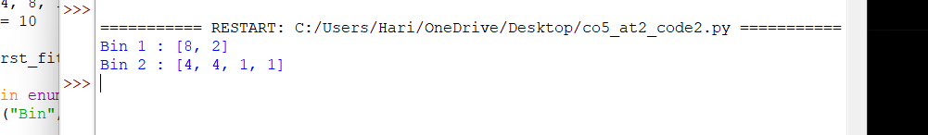
Output:

- Set of bins containing assigned items
Algorithm Design
- Sort items in decreasing order.
- Select the largest item first.
- Place it into the first bin with enough remaining space.
- Create a new bin if no suitable bin exists.
- Continue until all items are packed.
Major Steps
- Sort Items
- Search Existing Bins
- Assign Item
- Create New Bin if Required
- Repeat Until Completion
Approximation Nature
The algorithm does not always produce the optimal solution but generates high-quality solutions efficiently.
Time Complexity
- Sorting: O(n log n)
- Bin Placement: O(n²)
- Overall: O(n²)
Result
Items are packed successfully using only two bins.

Question 3: Bin Packing Approximation Using Best-Fit Strategy
Source Code (best_fit_bin_packing.py)
def best_fit(items, capacity):
bins = []

for item in items:

best_bin = -1
min_space = capacity + 1

for i in range(len(bins)):
remaining = capacity - sum(bins[i])

if item <= remaining and remaining - item < min_space:
best_bin = i
min_space = remaining - item

if best_bin == -1:
bins.append([item])
else:
bins[best_bin].append(item)

return bins

items = [4, 8, 1, 4, 2, 1]
capacity = 10

bins = best_fit(items, capacity)

for i, b in enumerate(bins, 1):
print("Bin", i, ":", b)
Title
Bin Packing Approximation Using Best-Fit Strategy
Problem Analysis
The objective is to place each item into the bin with the least remaining space that can still accommodate it.
Inputs
- Item Sizes
- Bin Capacity
Set of bins containing assigned items
Output:
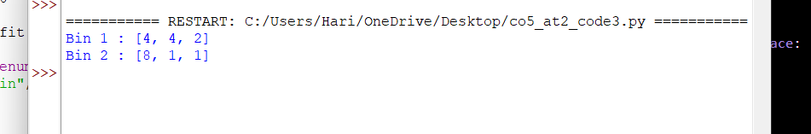
Algorithm Design
- Process items one by one.
- Check all existing bins.
- Select the bin that leaves the least unused space.
- If no suitable bin exists, create a new bin.
- Continue until all items are assigned.

Major Steps
- Read Item Sizes
- Search Existing Bins
- Find Best Bin
- Assign Item
- Create New Bin When Necessary
Approximation Nature
Best-Fit attempts to maximize bin utilization by minimizing wasted space after each placement.
Time Complexity
- O(n²)
Result
All items are packed successfully while minimizing unused space in bins.

